

Contents

List of Figures 2

Introduction 3

Aim 3

Objectives 3

Justification 3

Research 6

Study of Zoo and Smart Technology 6

Hardware and Software Requirements 6

ESP8266 Board Installation 13

Libraries 16

System Design 19

How the System Works 19

Development 20

Circuit Layout and The Build 20

The Sketch 23

Temperature, humidity and water quality monitoring: 23

People counter and Fire alert system: 27

Animal Feeder 31

RFID enabled door 32

Testing 35

Troubleshooting: 35

Testing of the Prototype: 36

Conclusion 37

# List of Figures

Figure 1: Rich Picture of the Proposed System 4

Figure 2: Android Application Layout 5

Figure 3: Arduino Uno 6

Figure 4: Breadboard 7

Figure 5: Jumper Wires 7

Figure 6: Ultrasonic Sensor 8

Figure 7: Smoke Sensor 8

Figure 8: Buzzer 9

Figure 9: DHT11 Temperature Sensor 9

Figure 10: Turbidity Sensor 10

Figure 11: Servo Motor 10

Figure 12: RFID-RC522 and RFID cards 11

Figure 13: Arduino IDE 12

Figure 14: Installing Library from .ZIP File 16

Figure 15: Installing Library from Library Manager 17

Figure 16: Circuit Diagram. 21

Figure 17: Final Prototype 22

# Introduction

Zoos have been around for many generations. Sometimes, zoos have problems of trespassing, fires, animal feeding, temperature and humidity problems, etc. These are various problems which can be solved with the implementation of pervasive computing solutions. Solving these problems will also make the lives of zookeepers easier. This project will allow zookeepers to keep track of temperature, humidity, and water purity and visitor count values. Notifications and buzzers to alert the zookeeper and the visitors when certain events occur such as fires will also be implemented. RFID door unlock will be used for zookeepers to access certain areas.

# Aim

To design and develop a prototype for zoo by implementing pervasive computing solutions.

# Objectives

* To understand how the implementation of pervasive computing can help to develop the proposed solution.
* To understand how all the sensor works and communicate with each other.
* To design and build a prototype by integrating Arduino, NODE MCU, MQ-2 Sensor, Ultrasonic Sensor, RFID TAG, Servo Motor, Turbidity Sensor, Buzzer, DHT 11 Sensor.
* To build a system that sends notification on mobile device alerting the zoo keeper in case of fire detection and replacing the water and display real time information in mobile app for temperature, humidity, Number of visitors and water quality.
* To test the developed prototype.

# Justification

The present condition of zoo is that it is difficult to keep track of the number of visitors at zoo. It is difficult to find out that the fire has occurred at the starting and only known when it’s huge so lots of animals get killed because of fire and visitors also gets caught in the accident. The zookeeper sometime forgets to feed all their animals on time. The visitors forgets that there are dangerous animals and go near the fence and try to feed the animals and gets caught on accident lost their life, gets their hand get eaten by animals when they try to feed dangerous animals by going near the fence. Animals have died inside the zoo because of unfavorable temperature and humidity for the animals and because of bad quality of water lots of water animals have been dead.

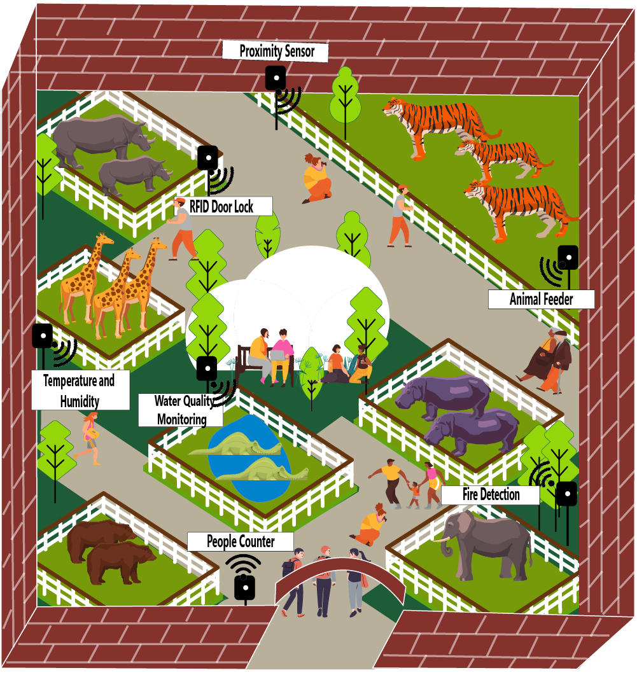

Figure 1: Rich Picture of the Proposed System

As shown in the above figure through the implementation of pervasive computing solutions these problems can be solved at zoo. It will be easier to keep track of number of visitors at zoo with the use of ultrasonic sensor. The ultrasonic sensor used in zoo will count the number of visitors who have entered the zoo .The MQ-2 Sensor is used to automatically detect the fire inside zoo in case the fire has occurred the sensor will detect the fire and buzzer will produce the beep sound so that people who are near the area where fire have occurred can become alert, also notification will be send in zookeeper mobile device alerting that fire has been detected and go immediately so that the zookeeper can go immediately where the fire has occurred which will help to minimize the loss of property and loss of life of people as well as animals inside zoo. The Animal feeder will help the zookeeper to feed the animals on time. The zookeeper does not need to take any risk to feed the dangerous animals with animal feeder. The proximity sensor is used to alert the people from going near the fence where dangerous animals are kept. If the people go too close to the fence the proximity sensor will detect the distance and alter the people not to go too near the fence through beep sound with the use of buzzer. DHT 11 sensor is used to detect the temperature of humidity at zoo and take measures for animals in case the temperature is too high or low for them so that the zookeeper can shift their animals to different places with favorable temperature. Water quality monitoring sensor is used to detect the quality of water for aquatic animals and if the water quality is too bad it will send notification to the zookeeper device altering water quality is bad and you should replace it. RFID is used so that only the zookeeper can enter inside the fence whenever he/she wants and to prevent from the unauthorized access. All the real time data are stored and displayed in single dashboard so that it will be easy for the zookeeper to find out what’s going on.

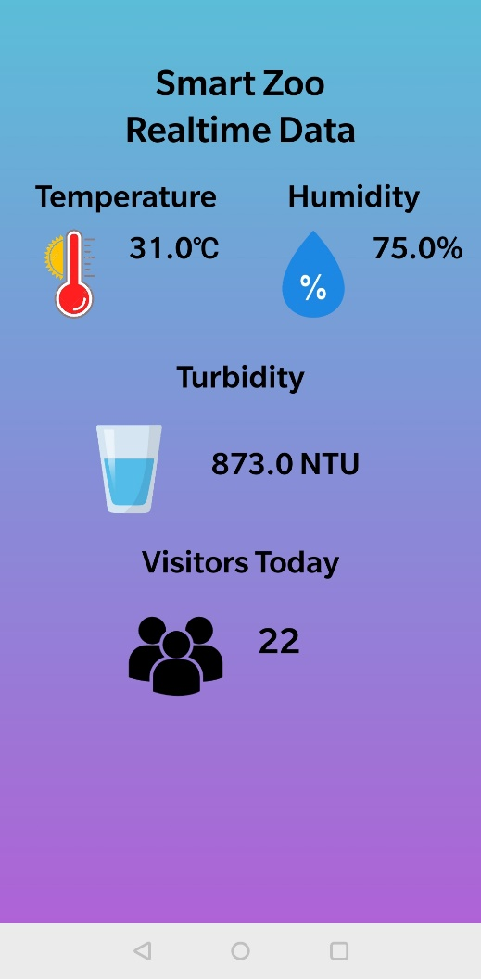

Figure 2: Android Application Layout

# Research

## Study of Zoo and Smart Technology

Smart Technologies can be used in order to make a zoo smart. We found out many smart technologies (ubiquitous devices) in our research in order to make a zoo smart. We found that ubiquitous computing devices such as NODE MCU, Arduino and different sensors can be used in making smart systems. Most of current zoos are not smart and they can be made smart easily with use of ubiquitous computing. In our research, we found that ultrasonic sensor can be used in counting no of people visiting the zoo. We also found that the same sensor can also be used in alert system for people approaching near the fence. We found that turbidity sensor can be used to determine the purity level of water. We also found that different animals in zoo may need different temperature and humidity so use DHT11 temperature sensor would be effective for measuring temperature and humidity of the zoo. Fire can occur at any place. So to take precaution regarding fire, smoke sensor can be used. In our research, we found that animal feeding in the zoo is quite difficult and takes lots of time. So we decided building a system of automatic animal feeder in certain interval of time. Furthermore, we found it is effective to use RFID cards in door unlock of zoo cage so that only authentic person can go inside the cage. All the above technologies are combined to build a smart zoo.

## Hardware and Software Requirements

Hardware required for this system are given below.

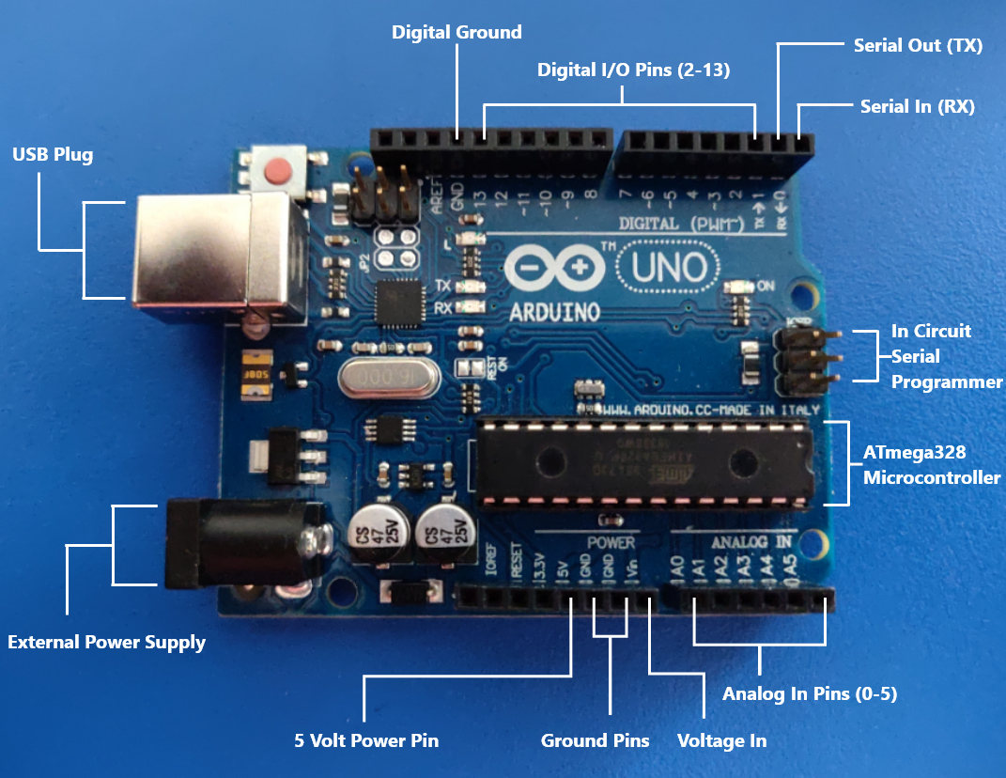

Figure 3: Arduino Uno

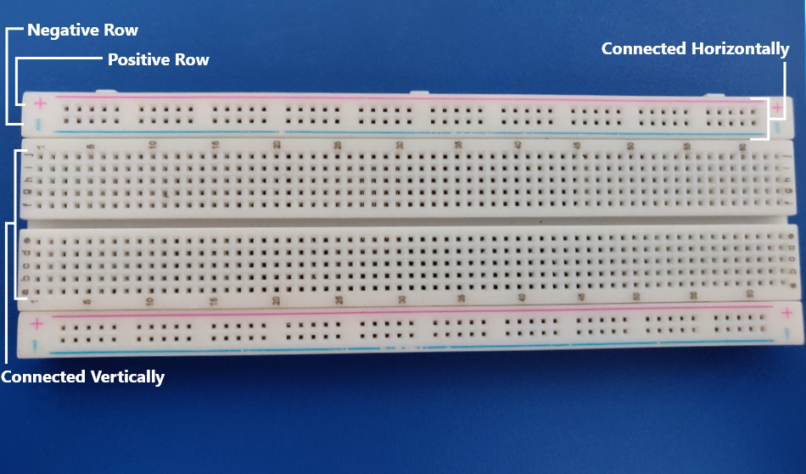

Figure 4: Breadboard

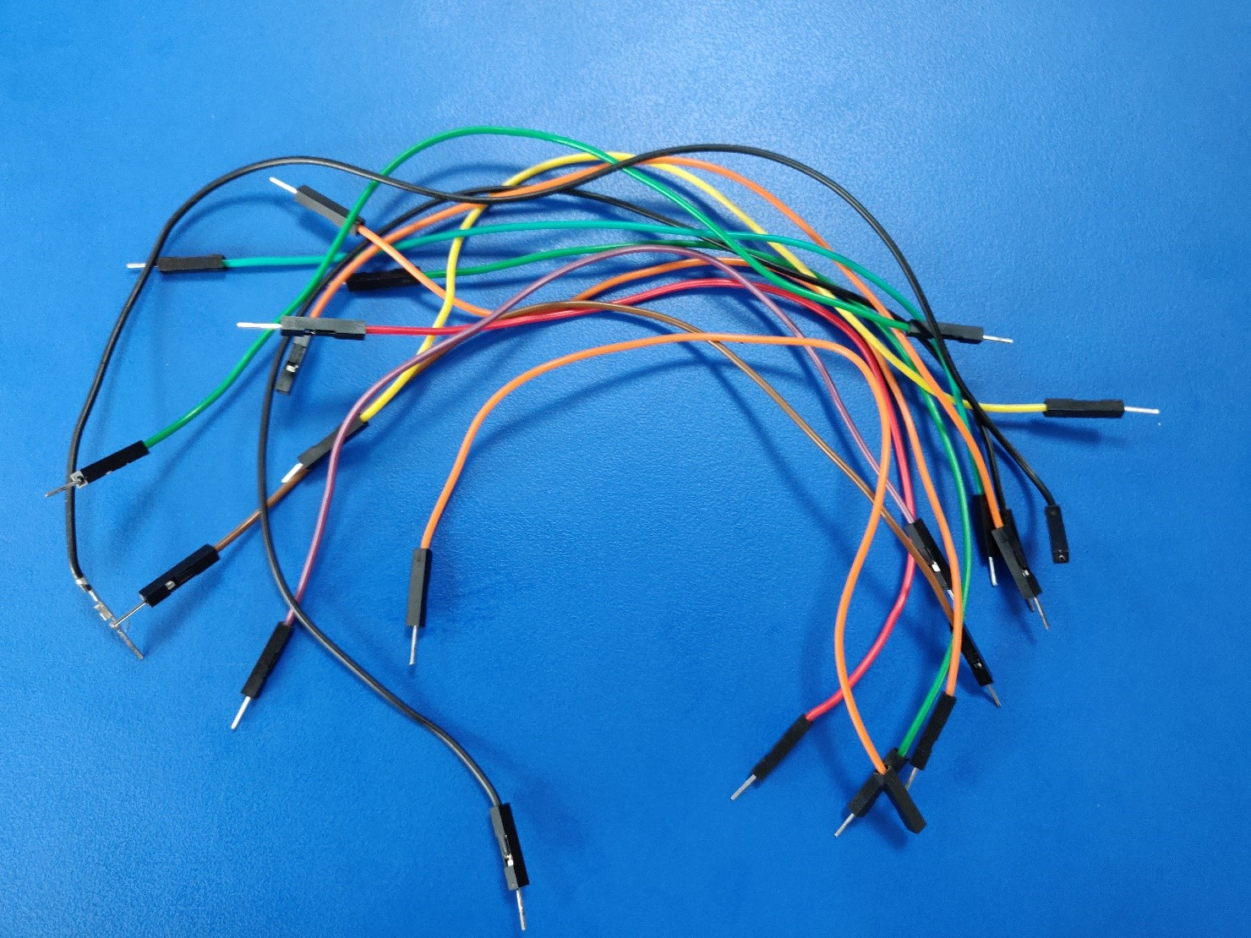

Figure 5: Jumper Wires

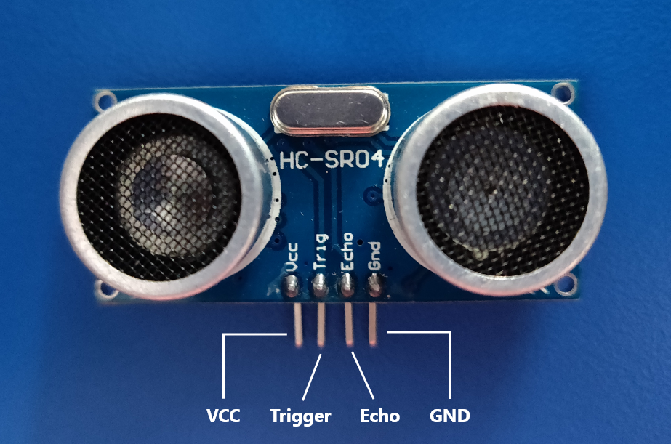

Figure 6: Ultrasonic Sensor

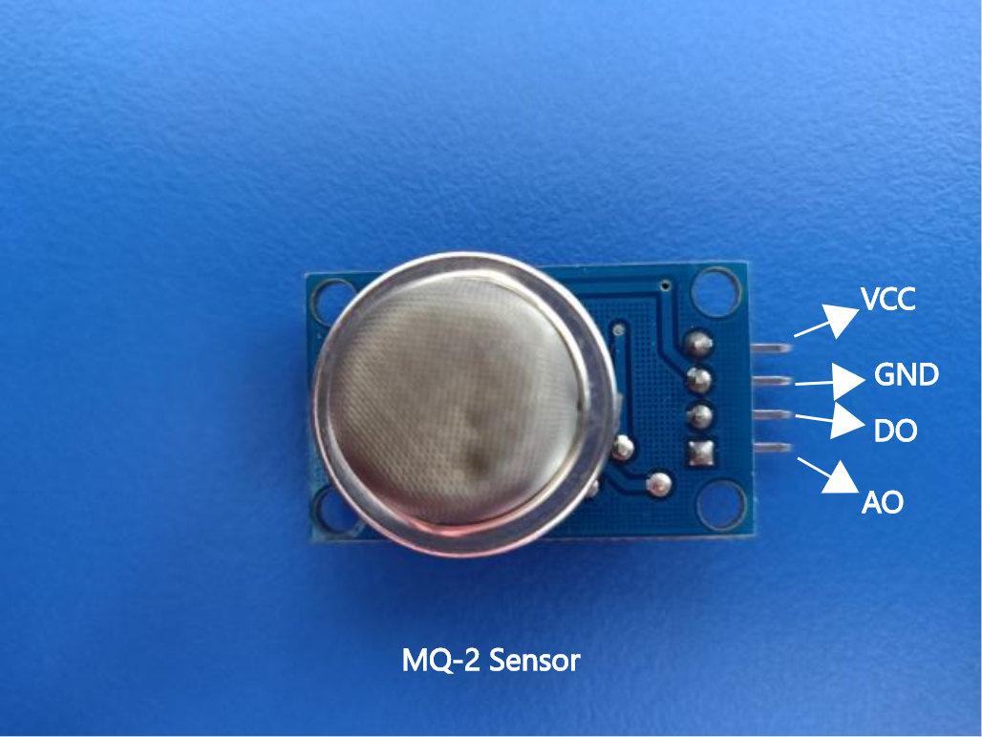

Figure 7: Smoke Sensor

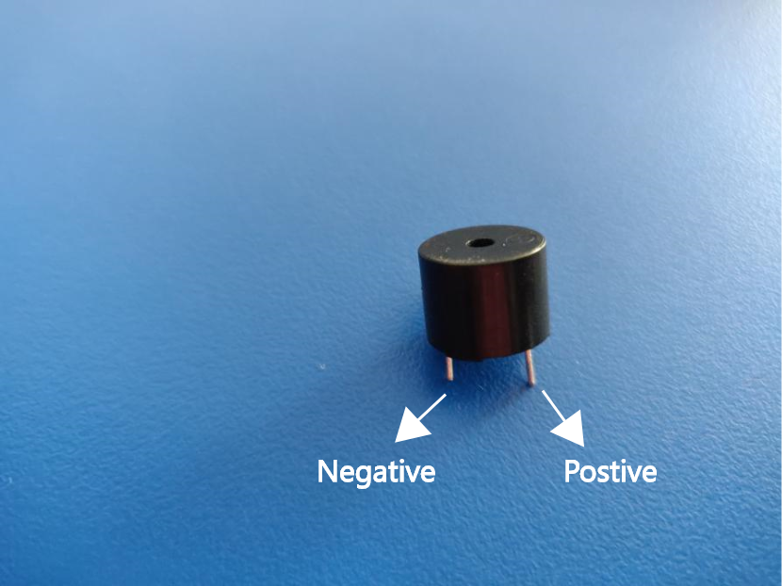

Figure 8: Buzzer

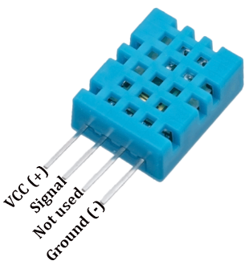

Figure 9: DHT11 Temperature Sensor

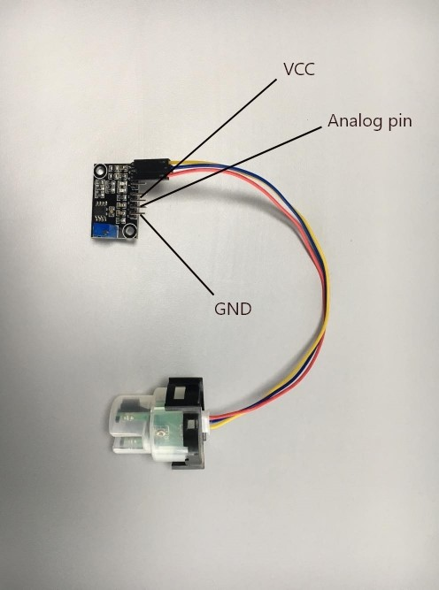

Figure 10: Turbidity Sensor

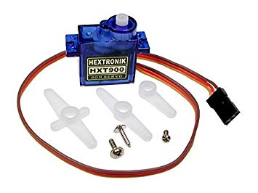

Figure 11: Servo Motor

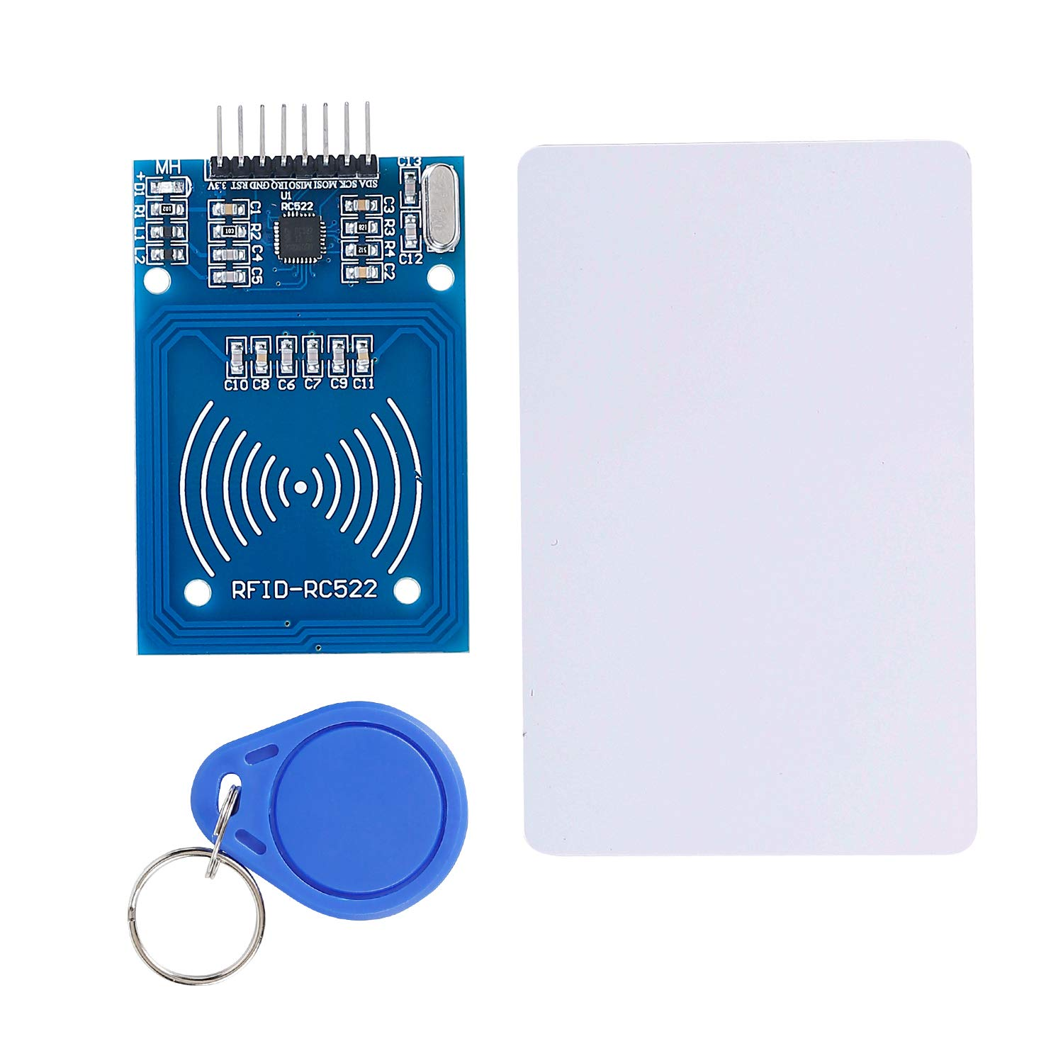

Figure 12: RFID-RC522 and RFID cards

Besides hardware requirements, we also need IDE (Integrated Development Environment) to sketch the necessary code for the project. So, in this project we are using Arduino IDE.

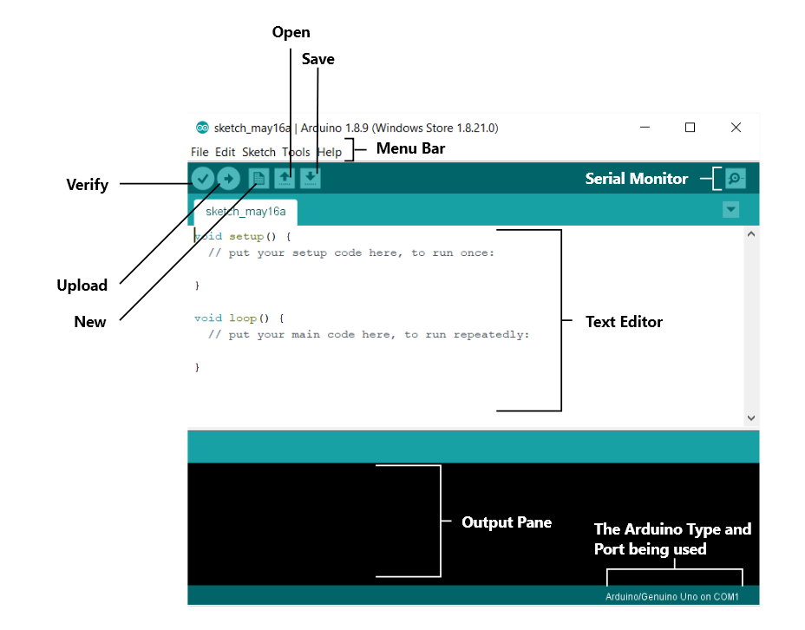

Figure 13: Arduino IDE

## ESP8266 Board Installation

As Arduino can’t be connected to WiFi, we need to install ESP8266 Board for connecting NODE MCU to Arduino IDE. So, first we need to install ESP8266 Board and for this follow the following steps.

* Click on File menu in the IDE and click on preferences.

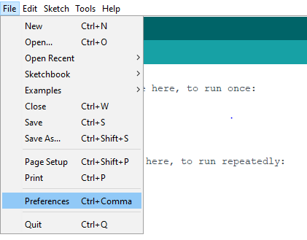

* Then paste this URL (<http://arduino.esp8266.com/stable/package_esp8266com_index.json>) in the Additional Board Manager URLs and click OK.

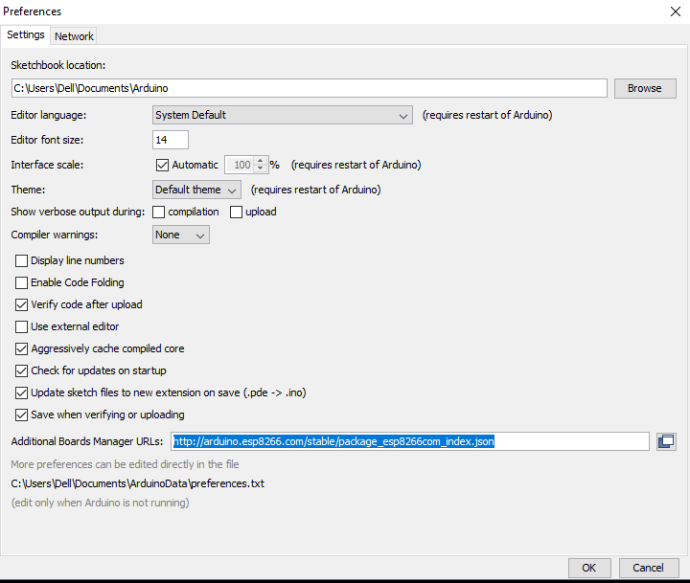

* Afterwards Click on Tools > Boards > Board Manager.

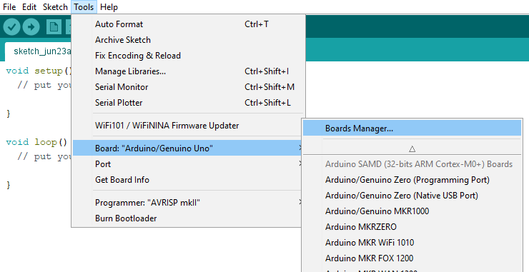

* Then search esp8266 and install the board.

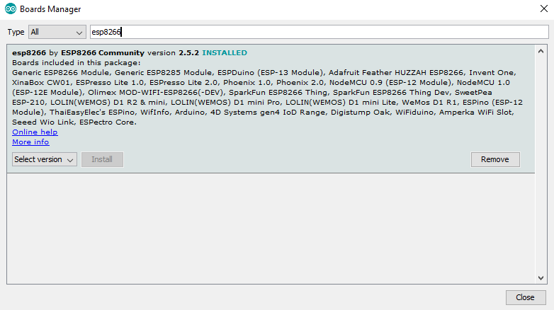

* Next click on Tools > Boards > and select ESP 12 E Module.

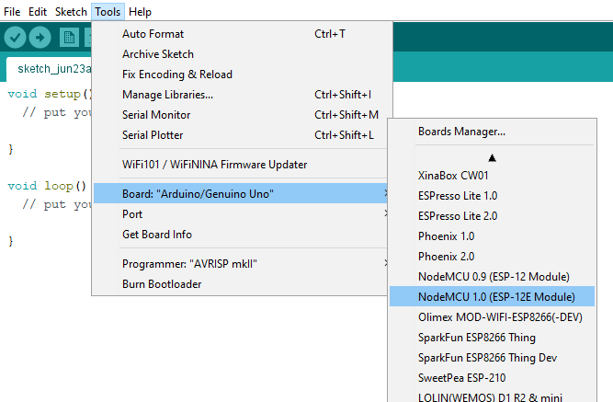

* Finally, we need to install a driver. For this go to this URL (<https://www.silabs.com/products/development-tools/software/usb-to-uart-bridge-vcp-drivers>), download the file and install it.

## Libraries

In order to achieve the aim of the project, we need different libraries for different sensors. So before we write the code for this system, we need to install libraries needed for each component of the system. There are two ways to install libraries in Arduino IDE.

* **Installing from .ZIP file**. In this installation, first we download the required library from the Internet and follow the following steps.
* First Click on Sketch > Include Library > Add .ZIP Library menu in Arduino IDE.
* Then select the downloaded library and Arduino IDE installs the library.

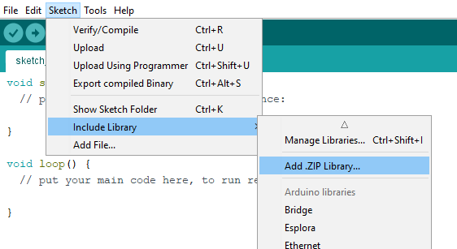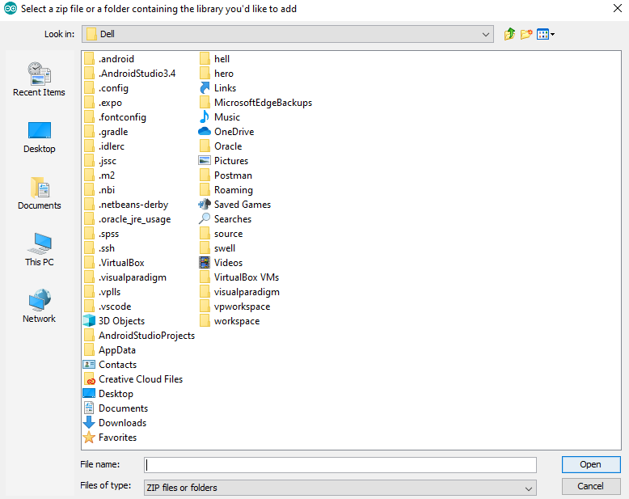

Figure 14: Installing Library from .ZIP File

* **Installing from Library Manager.** In this installation, we do not need to download the library file rather follow the following steps.
* First click on Sketch > Include Library > Manage Libraries… menu in Arduino IDE.
* Then search the required library and install the library.

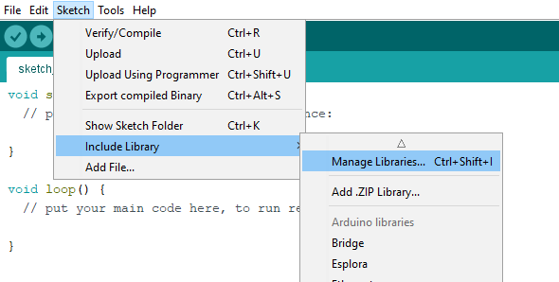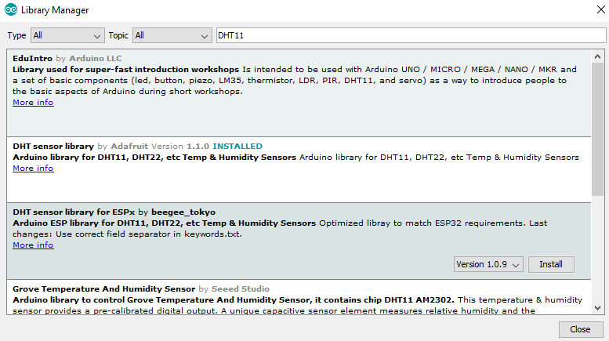

Figure 15: Installing Library from Library Manager

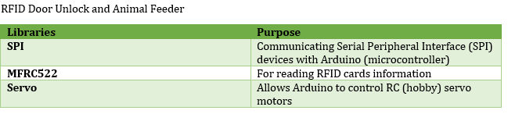

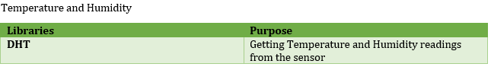

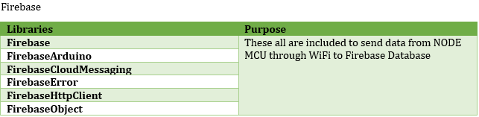

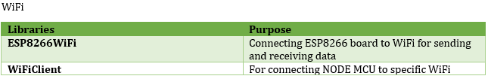

# System Design

## How the System Works

An ultrasonic sensor is an instrument which uses ultrasonic sound waves to measure the distance to an object. The ultrasonic waves reflect when they hit an object and produce clear echo pattern. A transducer is used in the sensor to send ultrasonic pulses and receive the echo to get information about an object’s proximity. Distance to an object is determined by the time taken between the sending and receiving of the ultrasonic pulses. The sensor used in the project is an HC-SR04 unit. The NODE MCU sends out a pulse on the trigger pin to send the ultrasonic burst and then receives the pulse on the echo pin using the pulseIn function. The time taken between sending and receiving the pulse is equal to the time taken by the ultrasound to hit an object and return back to the sensor. The time taken by the ultrasound is converted to distance by the NODE MCU.

Once the distance is determined, we can set threshold to this for taking further actions. In this project, we have set threshold of 7cm for counting people visiting the zoo. Once an object is determined within 7cm range, the value increases by 1. At the end of the day, we get no of people visiting the zoo. The real time data of visitors is also displayed in our android application.

A buzzer is also set on the breadboard to produce sound when people in the zoo approach very near to the fence. A threshold is set to 12cm and when it reaches is less than 12 cm, the buzzer starts to produce sound which alerts the people approaching near the fence of the zoo.

The MQ-2 sensor gives greater voltage if the gas concentration is more and gives less if it is low. We can set the threshold for the MQ-2 sensor to detect the smoke only when the smoke exceeds the expected threshold. The output from the MQ-2 Sensor may be analog (AO) or digital signal (DO) which can be read through the analog and digital pin of NODE MCU. It checks the logic level on the output pin of the smoke sensor and perform further task such as activating buzzer and sending alert notification to the owner’s mobile. The notification is sent through the service of IFTT.

A Turbidity sensor measure the amount of light scattered by the solids in the water, when the water is clean the sensor gets more light but when there are impurities present in the water like some solids the amount of light received by the sensor decreases. Here the sensor is activated all day long and it will gather data about the quality of the aquarium constantly throughout the day but, when it senses the quality of the water is poor and the threshold set is crossed it will trigger the NODE MCU to send an alert notification about the poor quality of the aquarium. This notification is also sent through the service of IFTT. Also, the turbidity value is sent to the firebase database and android application.

The DHT11 Temperature sensor senses the environmental temperature and humidity and sends it to NODE MCU. The NODE MCU is programmed such that the values of temperature and humidity are sent to the firebase database and further sent to the android application. The real time data are shown in the application so that owner knows the temperature and humidity in the zoo and perform the necessary actions when the values shown are not normal.

Servo motor has been used in animal feeder. It is connected to Arduino and is triggered in certain interval of time that we set. In this project, we have set the interval of 10 seconds. In this interval of time, the servo motor rotates its wheel 900 and the food in the food holder is dropped. After 3 seconds, the servo motor rotates its wheel 900 and returns to its original position such that the dropping hole of the food holder is fully covered so that food is not dropped now. The food feeding system is made automatic by the use of this system.

Another servo motor has been used in RFID (Radio Frequency Identification) door unlock system.  Each RFID card has a unique ID embedded in it and a RFID reader is used to read the RFID card no. It is connected to Arduino and is triggered when RFID card is shown to the RFID reader. When the authenticated RFID card is shown, the door unlocks itself and when the unauthenticated RFID card is shown, the door does not unlock and triggers the light in red led. This system ensures only authenticated person can unlock the doors of the zoo.

# Development

## Circuit Layout and Build

Water quality monitoring system:

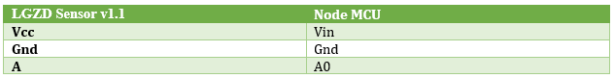

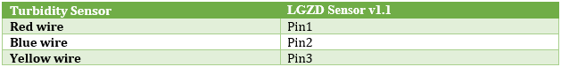

For people counter:

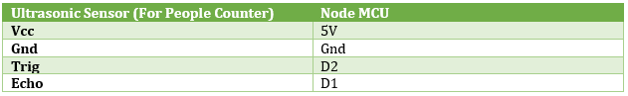

Proximity Alert System:

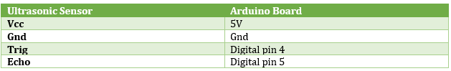

RFID door:

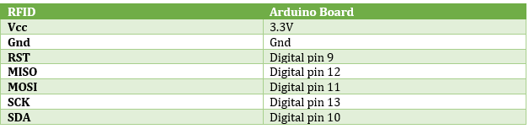

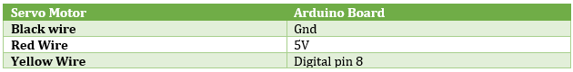

Temperature and humidity monitoring:

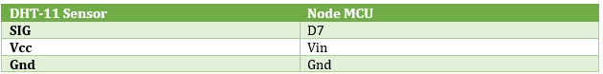

Fire alert system:

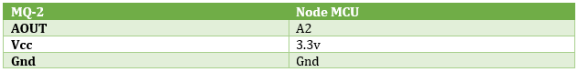

Animal feeder:

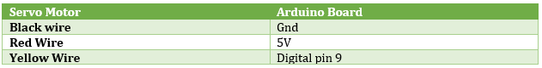

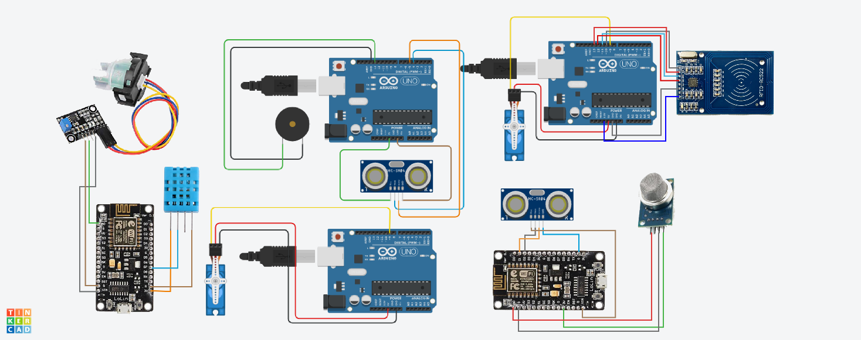

Figure 16: Circuit Diagram.

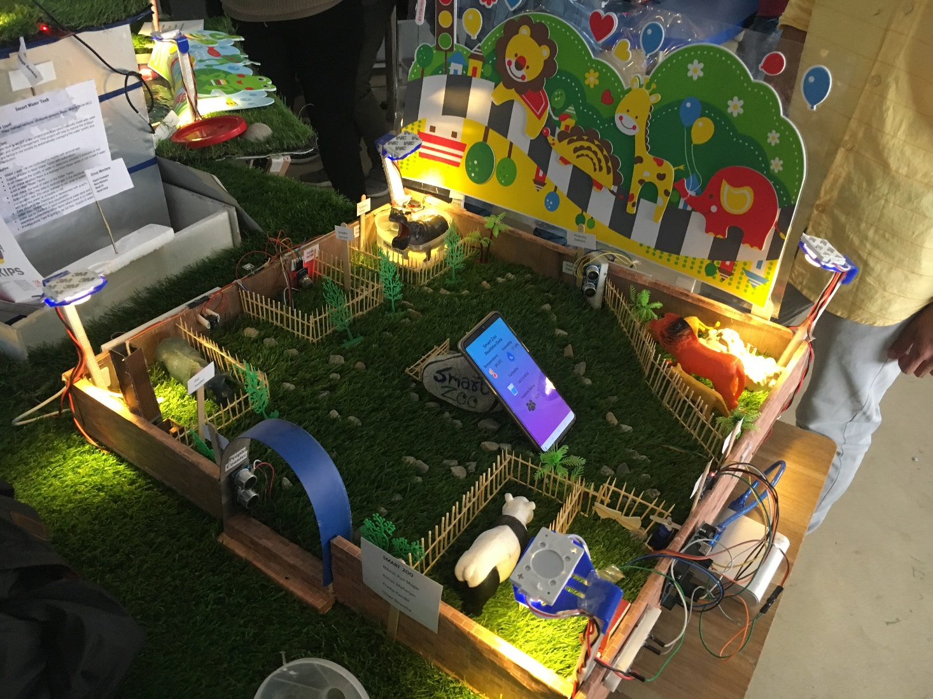

Figure 17: Final Prototype

## The Sketch

### Temperature, humidity and water quality monitoring:

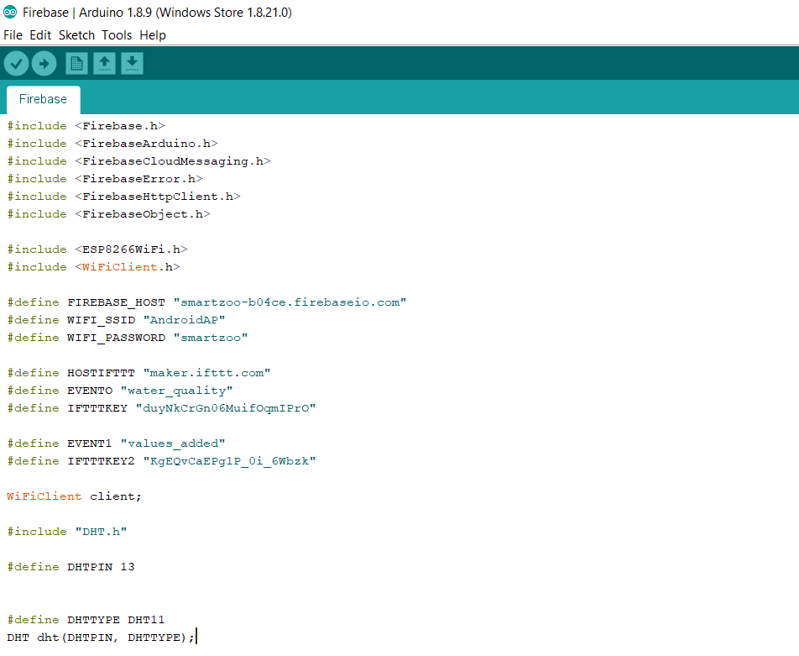

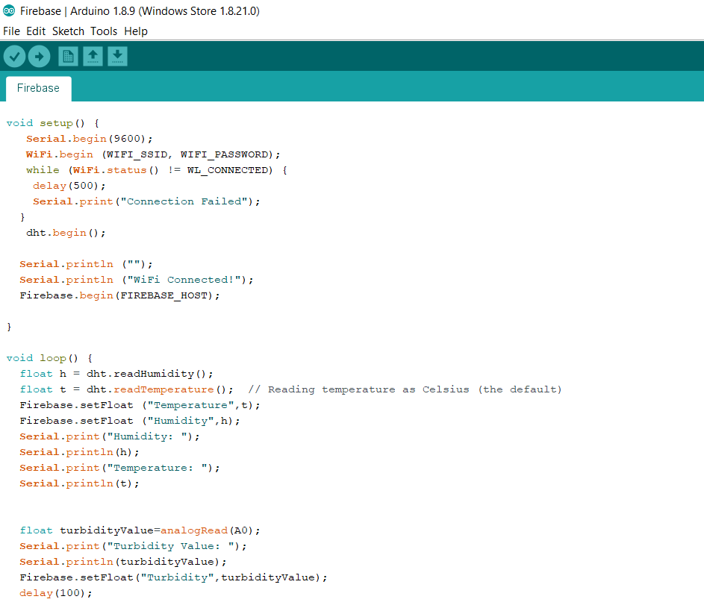

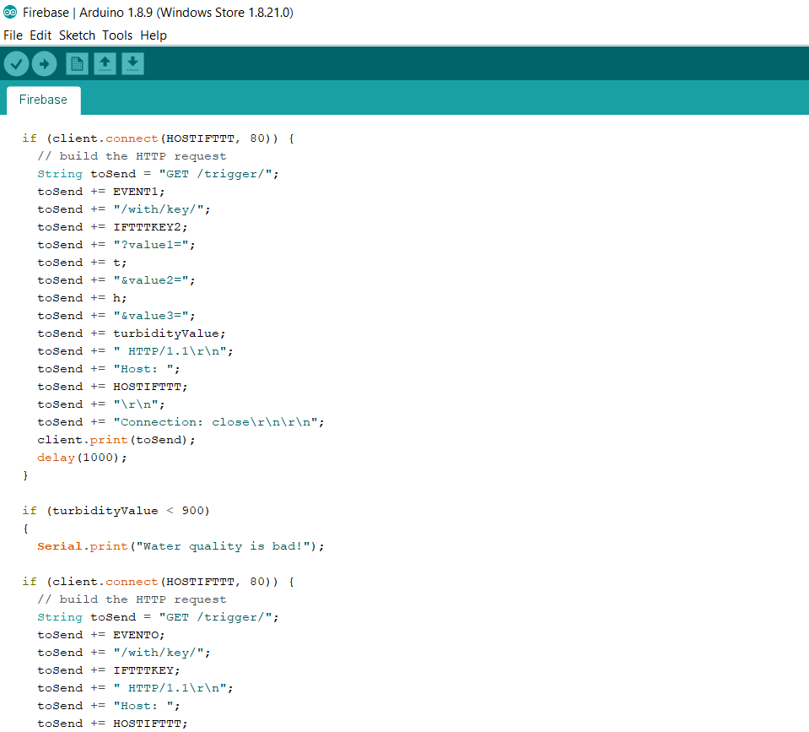

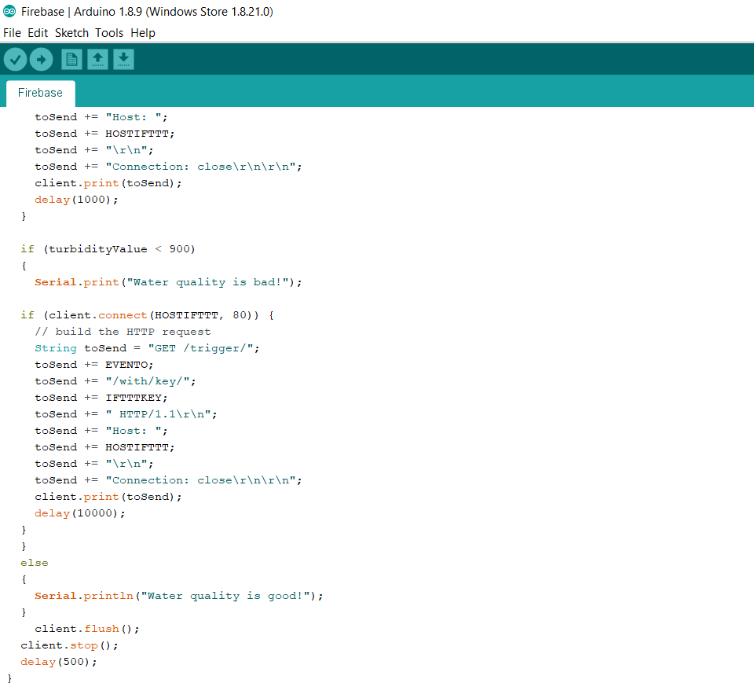

### People counter and Fire alert system:

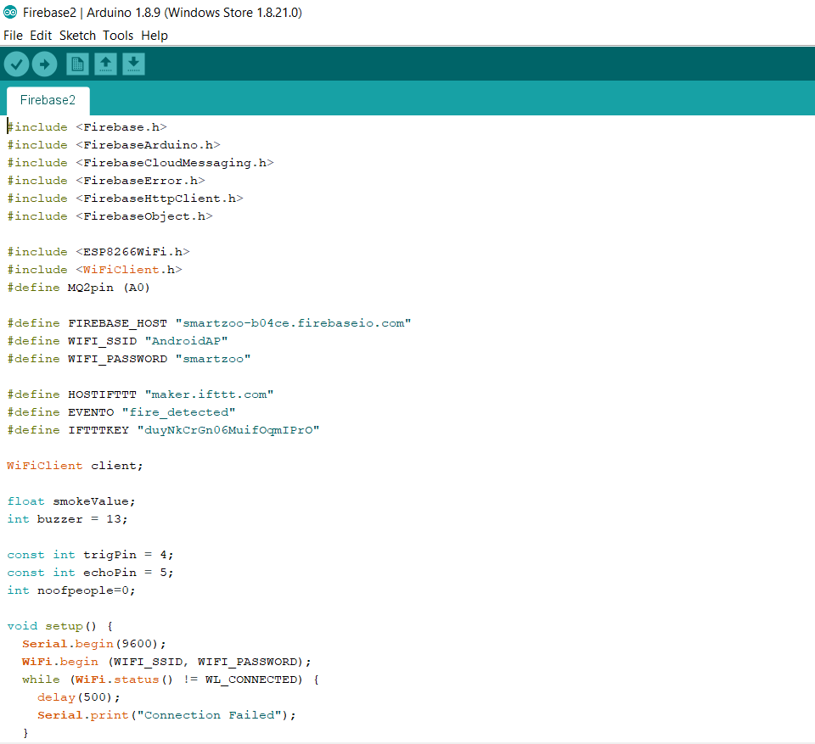

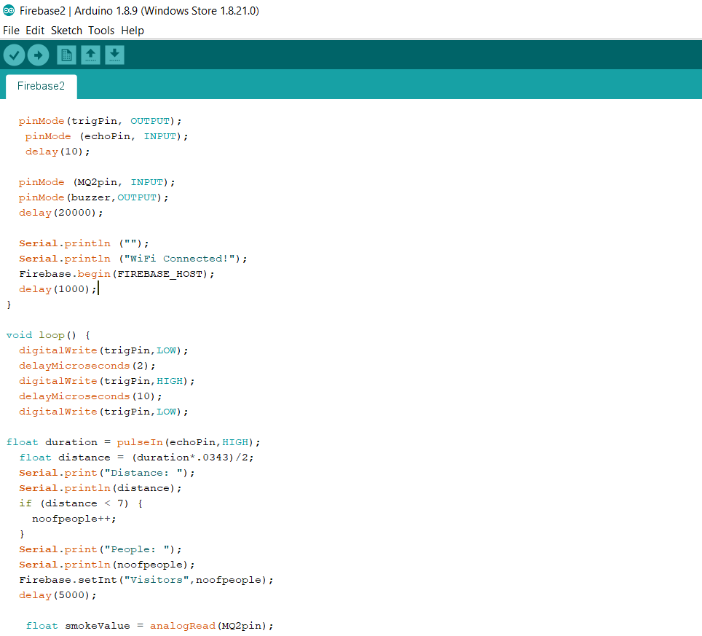

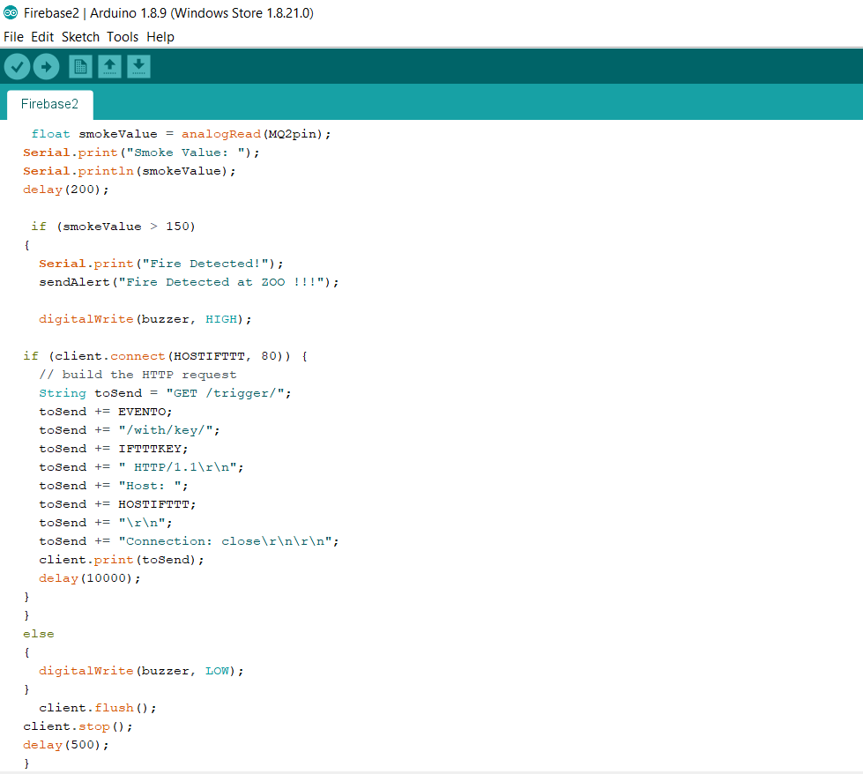

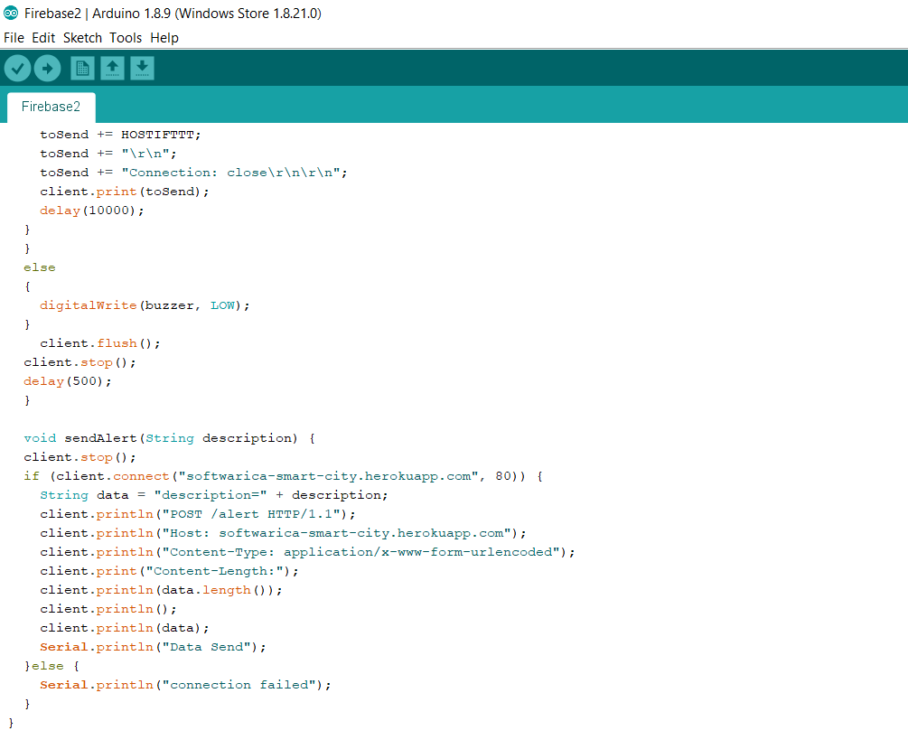

### Animal Feeder

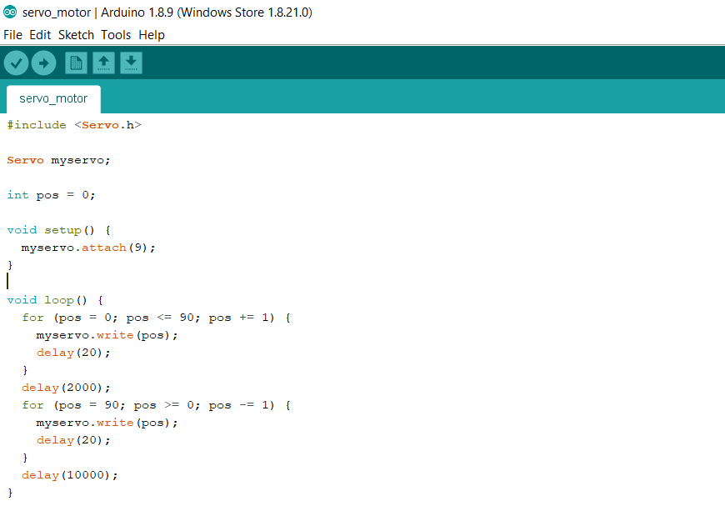

### RFID enabled door

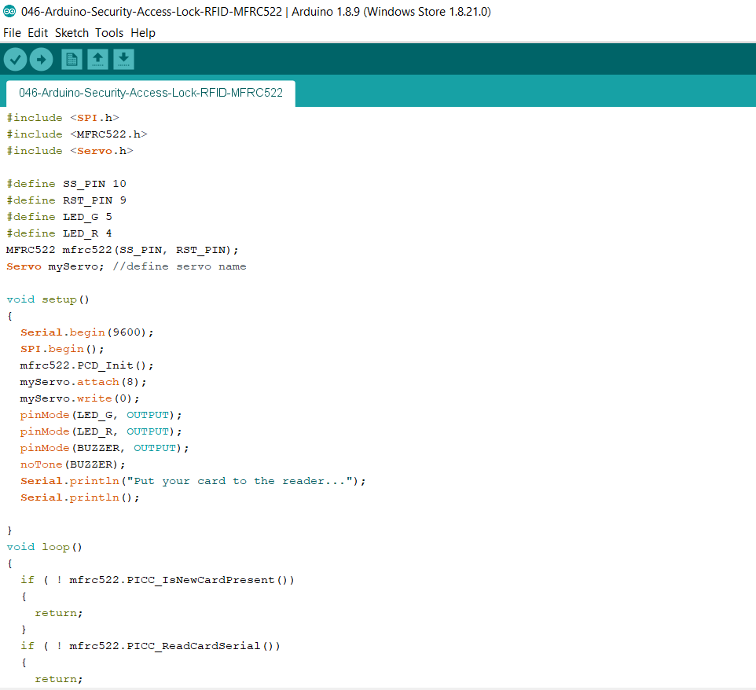

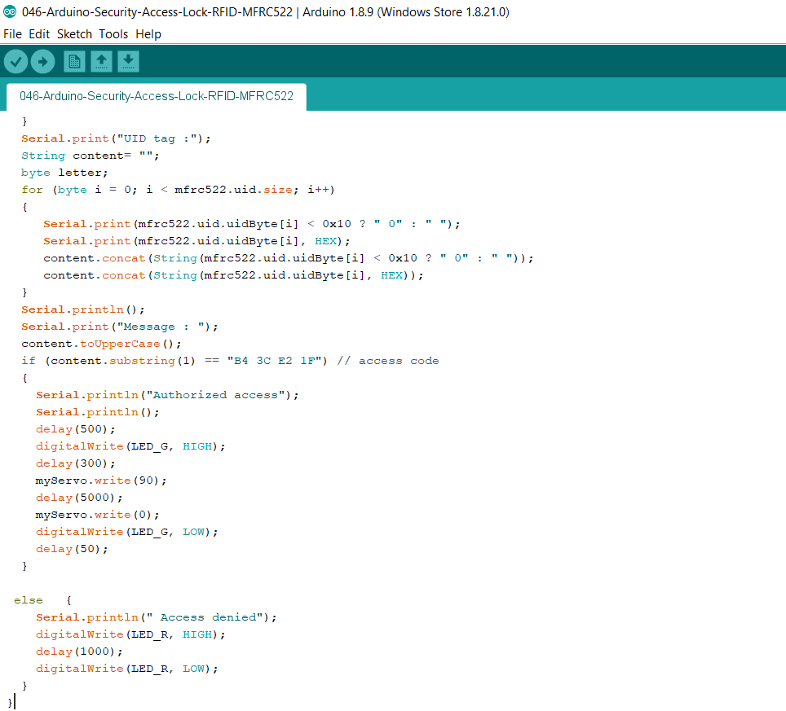

Proximity Alert System and Automatic Lights

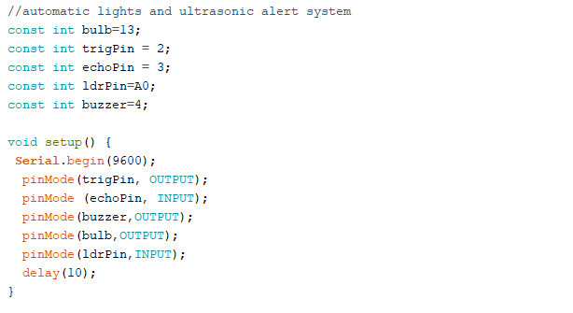

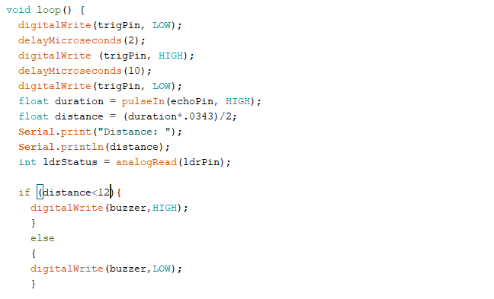

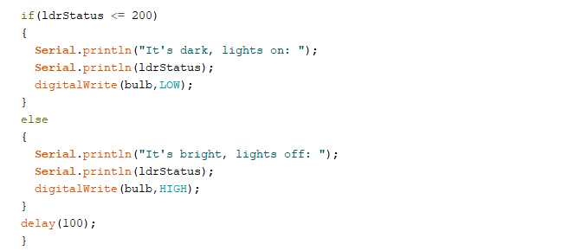

# Testing

Testing is an important part of the system development. Firstly our individual project and the components were gathered and tested on the node mcu as we had to make our individual project’s data and information to go to database and store. There were some problems and troubleshooting were done to make our project set-up work on node mcu.

## Troubleshooting:

Some troubles which we faced during the system for smart zoo development are given below along with their solutions:

Q. The water quality monitoring keeps on giving false reading.

* Check the wiring of turbidity sensor with the LGZD v1.1 sensor and LGZDv1.1 sensor to the Arduino board. Connect red, blue, and yellow wire of turbidity to the 1, 2 and 3 labeled port of the LGZD v1.1 sensor for correct reading.
* Check if the wires are loosened, sometimes lose wires give false reading. Tighten the wires joining.

Q. The people counter doesn’t work.

* Check if the WiFi is working or not. If the internet is down the nodemcu cannot send data to the firebase and the people count will not increase.
* Check if your device is connected to the internet or not.

Q. RFID key does not work.

* Check if led is working or not if the led is working and the door is not opening there might be problem with the servo motor.
* If that’s the case check the power supply. We had used battery so sometimes the battery rat out and was unable to supply enough power to the servo motor.
* If both led and servo motor aren’t working then check the connection of the RFID. Might be problem with RFID.

Q. DHT-11 sensor is giving the wrong reading.

* DHT-11 sensor some with labeled holder and sometimes it in without it. In our case it was not labeled so we had wired the sensor read pin at wrong pin of the DHT sensor. To solve it hold the sensor as to net like squares facing you then connect the reading pin to the 2nd pin from the left side. Left one is Vcc and right most is gnd.

Q. Proximity alert system doesn’t work.

* Check the buzzer. Check the buzzer in the Arduino board and set it high just to check if its working or not. We had to change the buzzer because one of them was faulty.
* Check the ultrasonic sensor is in correct spot. The waves from the trigger of the ultrasonic sensor needs to be received by Echo to get correct reading so make sure the trig is facing on a plain wall or something else you might receive an false reading which might result in proximity alert system not working correctly.

## Testing of the Prototype:

After testing the individual projects and assembling them together, testing was done to test whether the system worked or not as a single system. The problem we faced was that node mcu had only one analog read pin. Therefore, two node mcu were used to send 2 different analog read data of the smoke and turbidity sensor for smoke alert and water quality monitoring in real-time. For all the other parts like animal feeder, RFID and proximity alert system single Arduino could have been used but it was all messy and those systems were far apart from each other correspondingly so three Arduino boards were used for the system separately in order to reduce the wire usage and also to reduce the load on single Arduino. During testing phase separate battery were used to power separate Arduino but on the long run the battery were drained so fast that several batteries were changed, this seemed inefficient on the long run so it was better to use an adapter to power the Arduino directly from the power socket.

# Conclusion

Thus, the project of creating a smart zoo has been completed successfully. The main features of the designed prototype were to display real-time data of temperature, visitor count, turbidity etc. to the zookeeper’s android device and also send notifications according to the event such as smoke detection, water turbidity decrease, etc. The RFID enabled door and the animal feeder were also built which helped to make the zookeeper’s work easier. All tasks and sub tasks have been completed. Different problems were experienced and solved during the project. This project also helped us learn about Firebase Real-time Database and the sending and storing of real-time data using Node MCU and also helped us learn about various kinds of sensors and devices which helped us perform more on Arduino. Overall, this project helped us to learn about the benefits of pervasive computing and how sensors can be implemented in real-life scenarios for our benefit.